Operating Systems
Lab 1
For each question, you need to take a screenshot of the Linux commands you use and the results of the commands and put the screenshot under the question. You may use this link, https://kb.iu.edu/d/afsk , to find the Linux commands you may need to use.
- Show the current working directory.
(Example output)
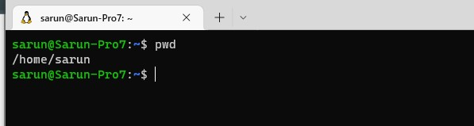
- Create a subdirectory “sub1” under your home directory.

- Change to subdirectory you created in the previous question.

- Create a text file using the following command cat > test1.txt. Then enter a few lines of text then press ctrl-d to save the file.
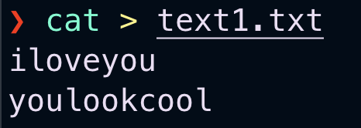
- Create a subfolder sub11 under your current directory.
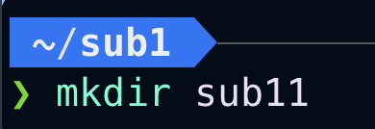
- List the files and folders in your working directory.
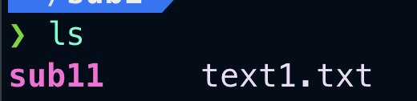
- List the files and folders in your working directory by showing properties such as permissions, owners, and sizes.
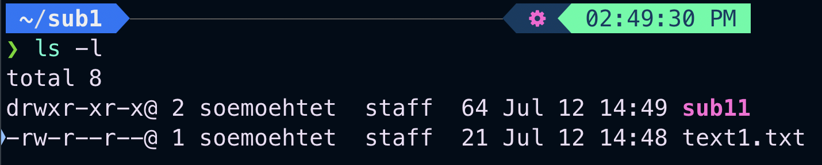
- How can we tell the difference between a file and a folder from the result of the command in the previous question? (For this question, you may give only your explanation without any screenshots)
how to distinguish between files and folders using the output of the ls -l command in Linux:
File type: The first character in the output indicates the file type.
For regular files (containing data or text), it will be a hyphen (-).
For directories (folders used to organize files), it will be a lowercase 'd'.
Size: Files will have a size listed in bytes, while folders will show a total size of 0 bytes since they don't store data themselves, only references to the files they contain.

- List the files and folders in your working directory including the hidden files.
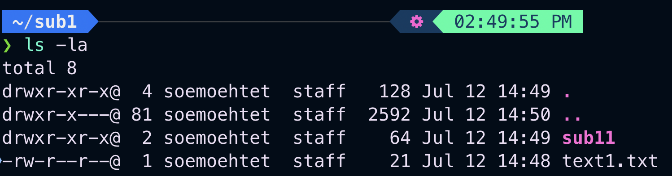
- Copy the contents of the test1.txt to the new file test2.txt.
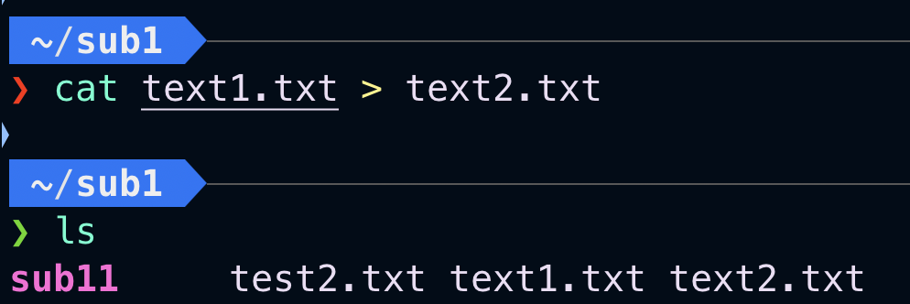
- Copy the contents of the test1.txt to the new file test3.txt.
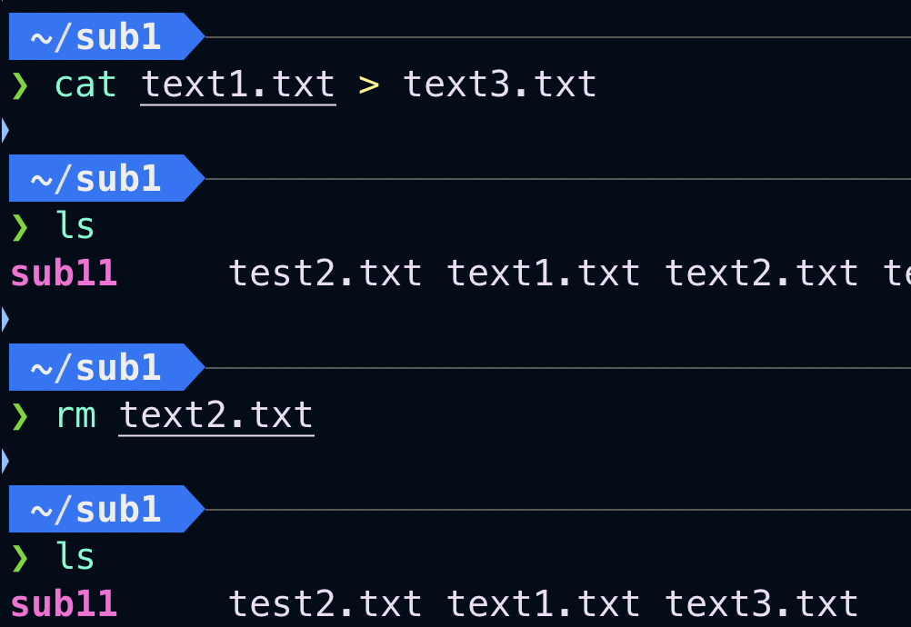
- Rename test2.txt to test2.dat.
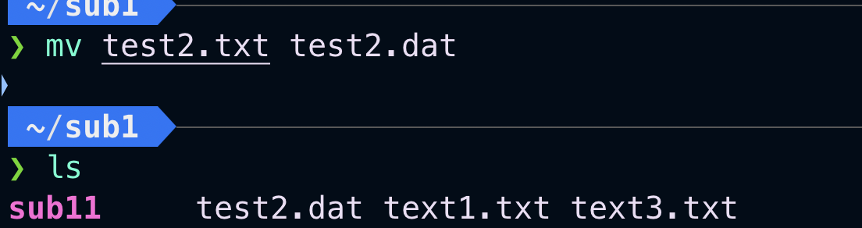
- Delete the file test3.txt.
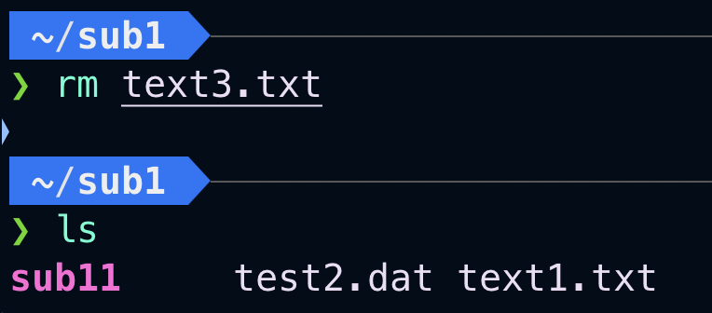
- Delete all files in the folder sub1.
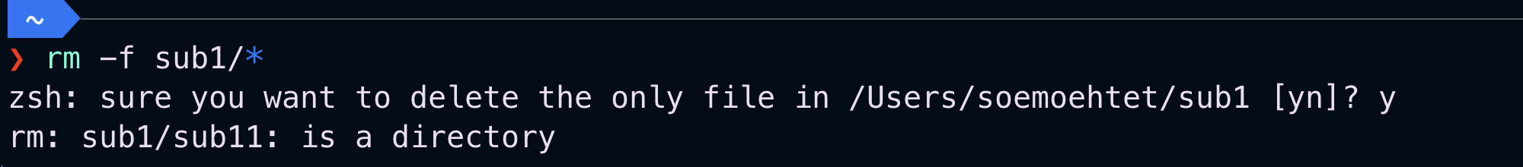
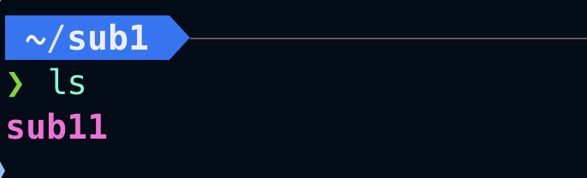
- Go back to your home folder.

- Create a folder sub12 under sub1 without changing to sub1 first.
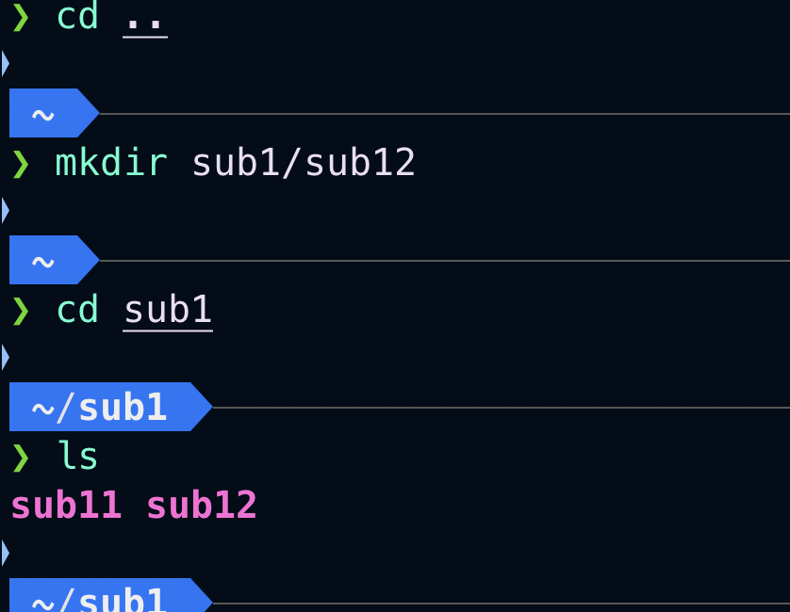
- Go to folder sub1

- Create the following files in the folder sub1, file1.txt, file2.dat, file3.doc, file4.txt, file5.txt, file11.txt, and file21.dat. (Hint: The easiest way to do this is to use the
“touch” command. However, if you do not know how to use “touch,” you can use a text editor to create those files or create one file and copy the contents to the rest. You do not need to take a screenshot or answer anything for this question.)
- Copy only the files whose names begin with “file” and follow by only one digit from folder sub1, i.e., copy only file1.txt, file2.dat, file3.doc, file4.txt, and file5.txt to folder sub11. You need to use only one cp command.
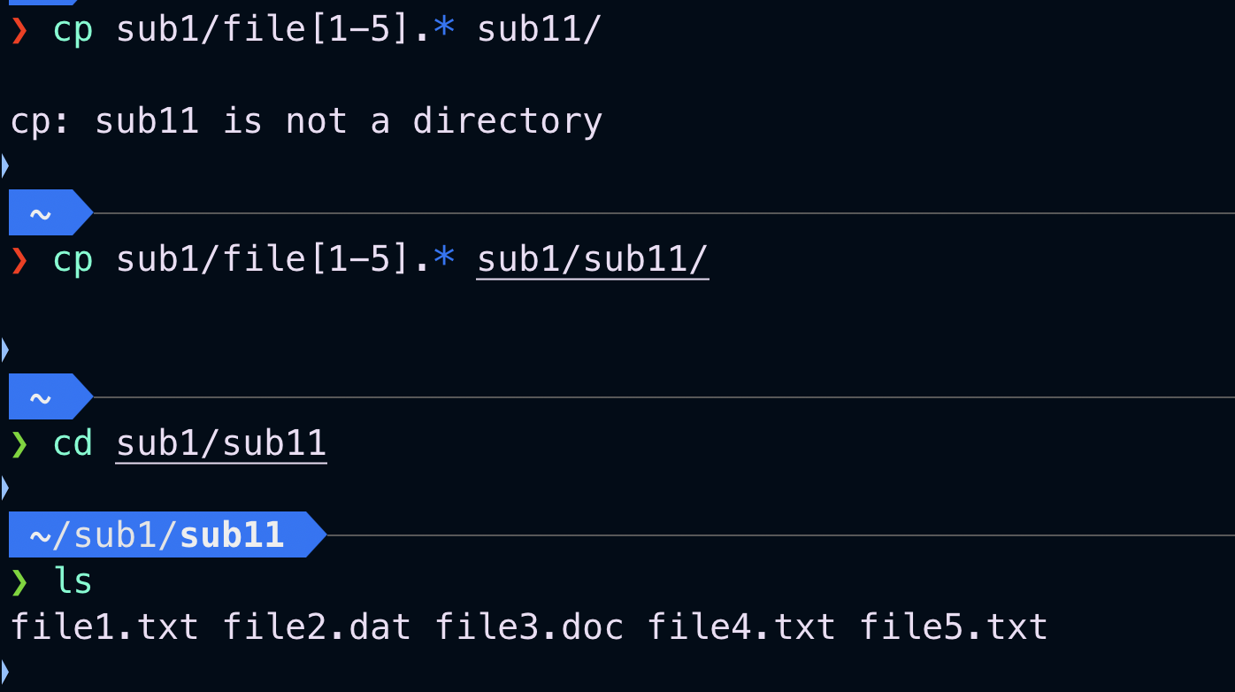
- List the files in folder sub11 without changing to the folder sub11 first.
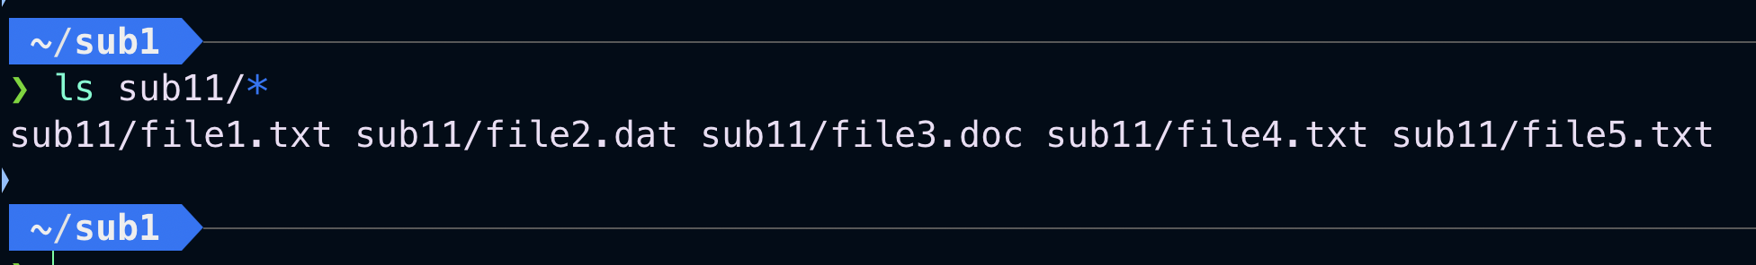
- Show the manual of the ls command.
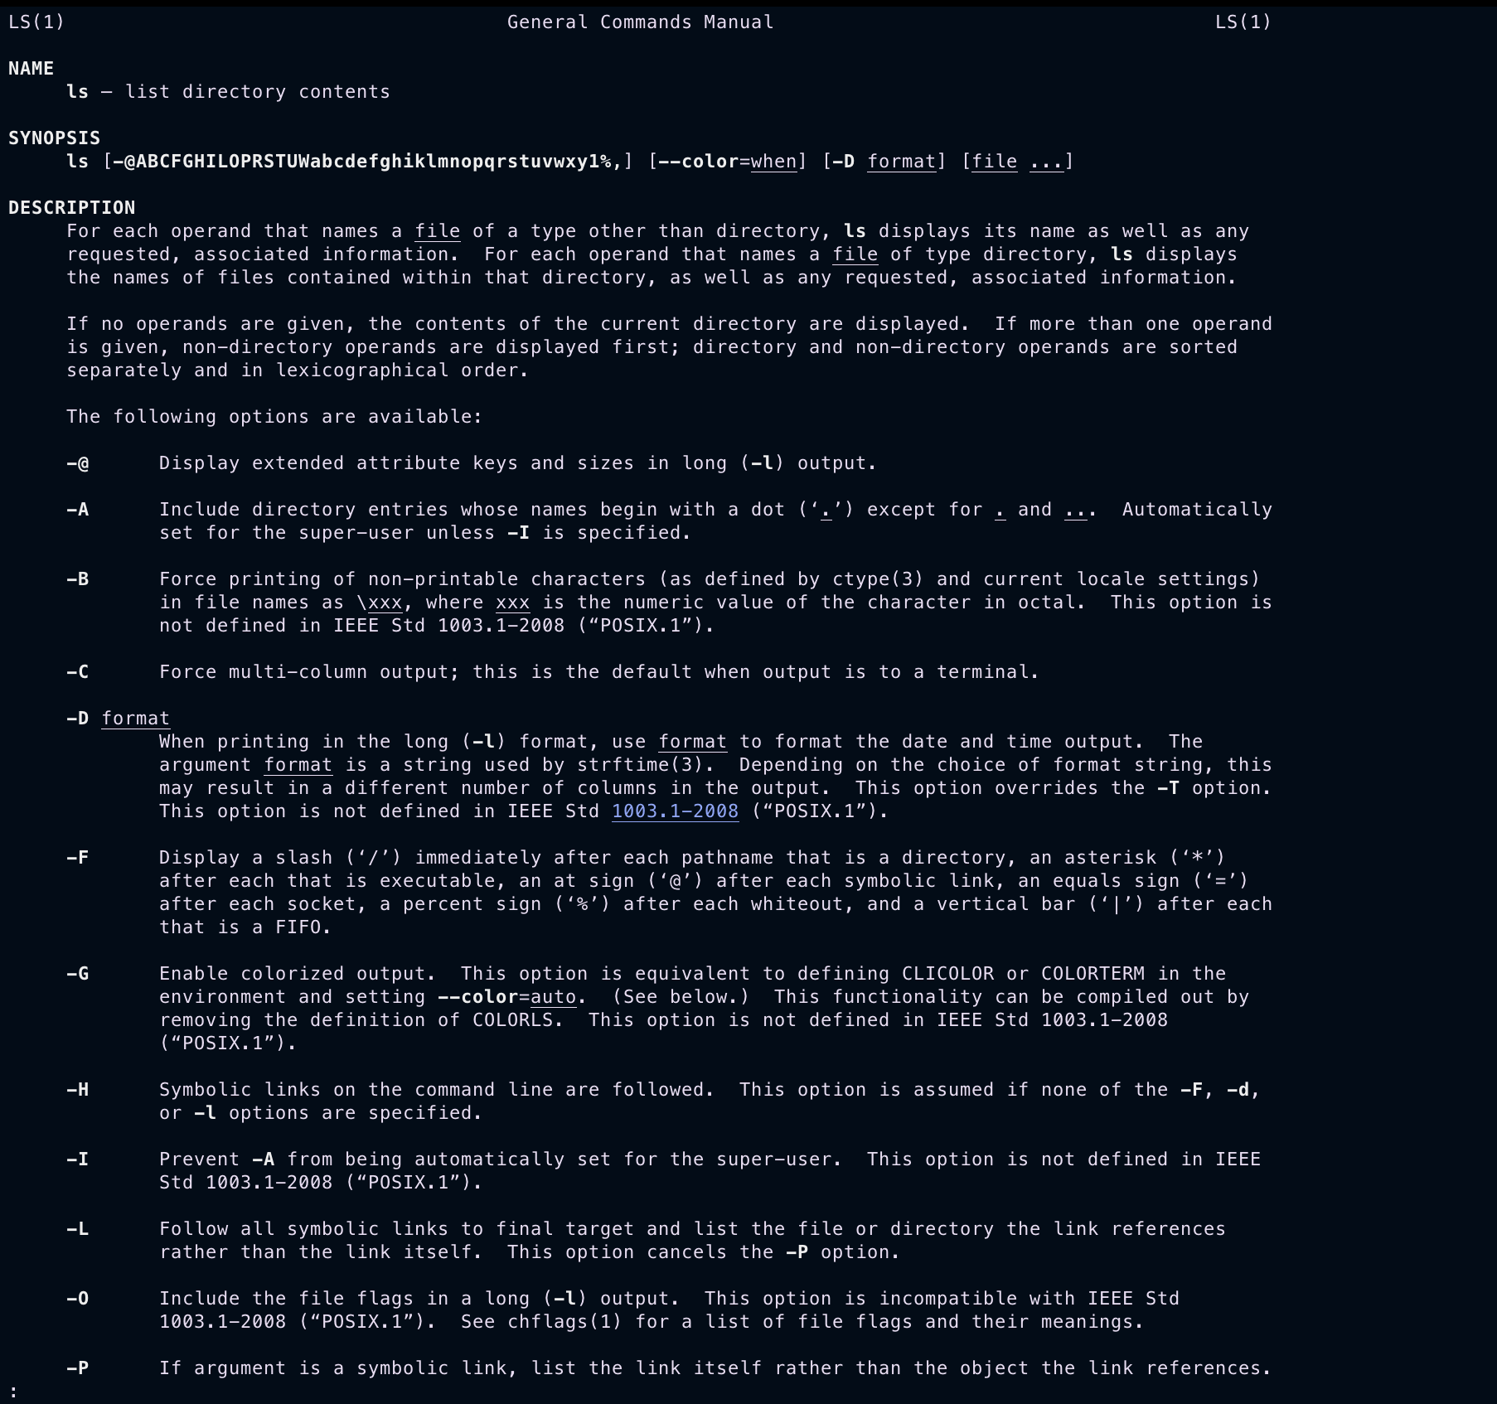
- Show the list of files in folder sub1 and you sort the result based on the extension in the ascending order.
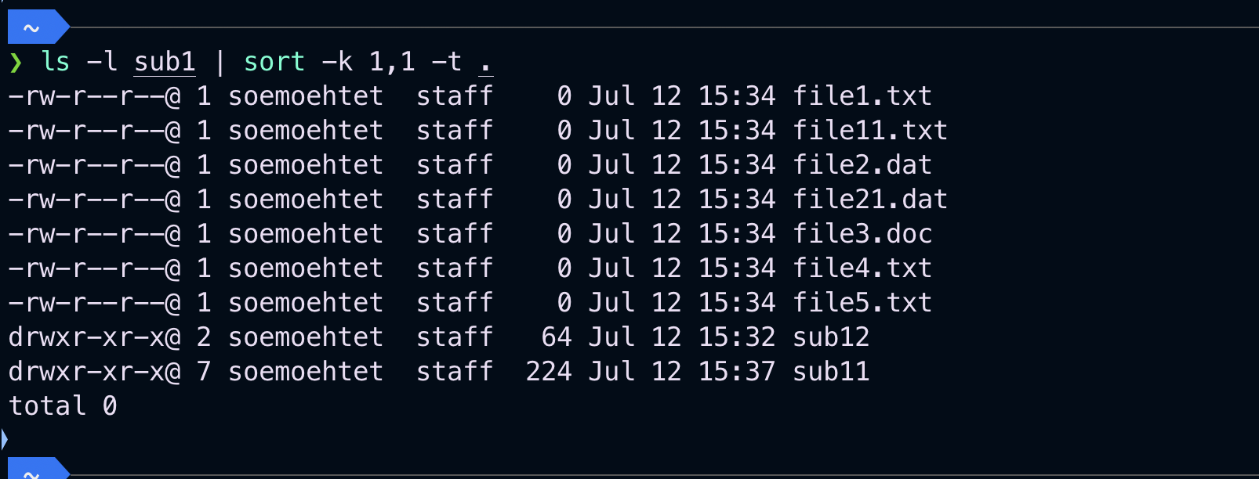
- Remove the folder sub12.
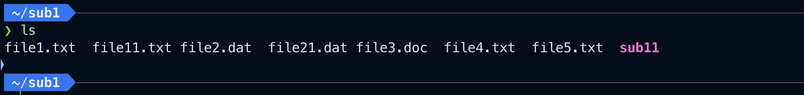
- Remove all files in folder sub11 using only one command.
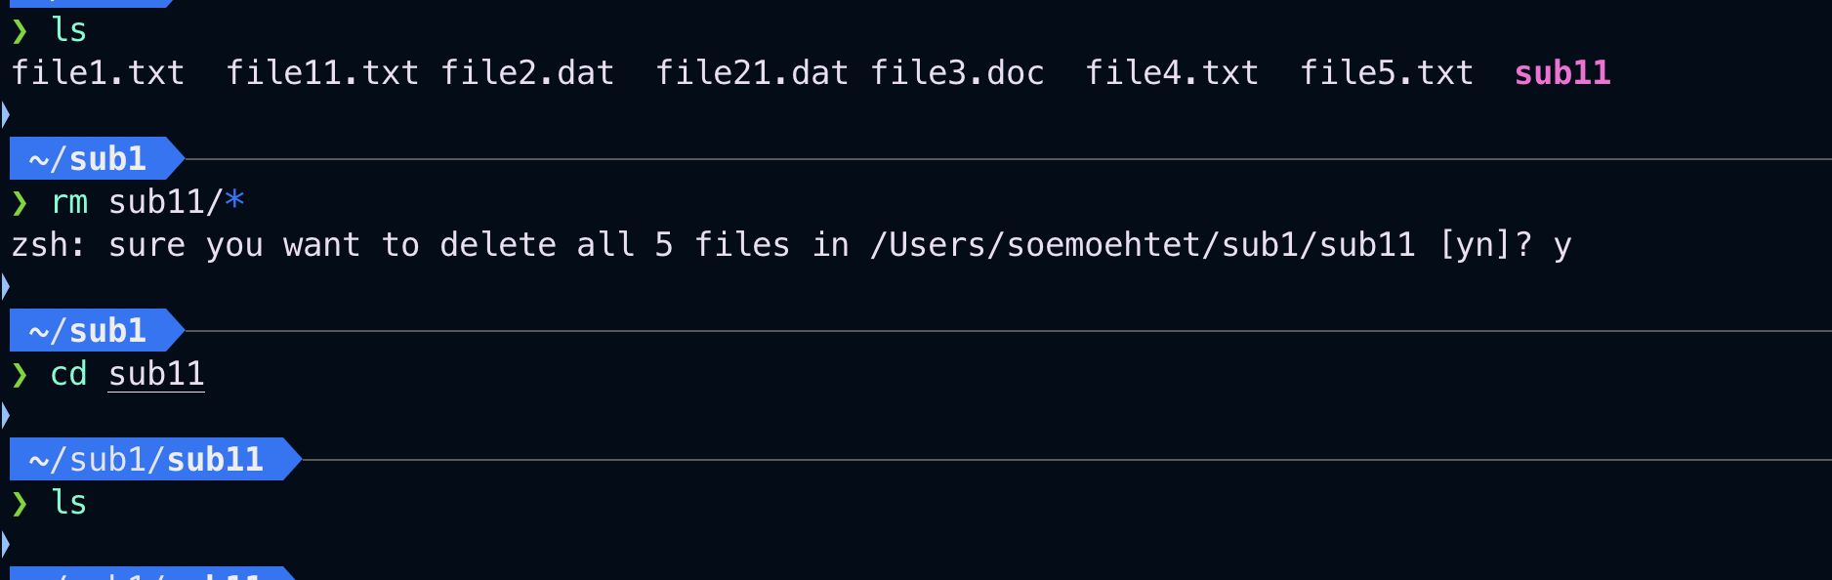
- Go back to your home directory.
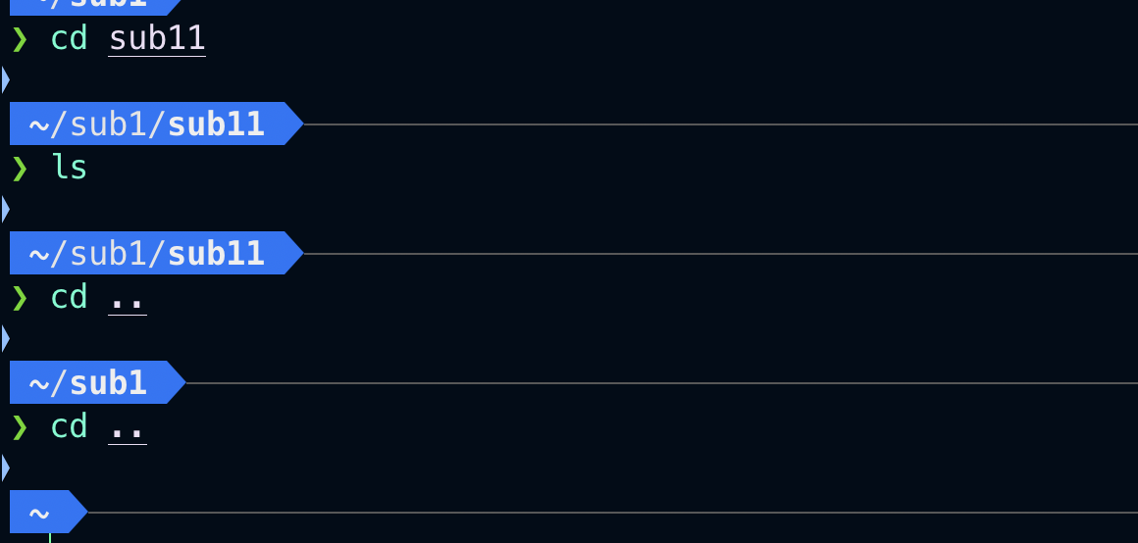
- Create folder sub11 under sub1 without going into sub1 first.
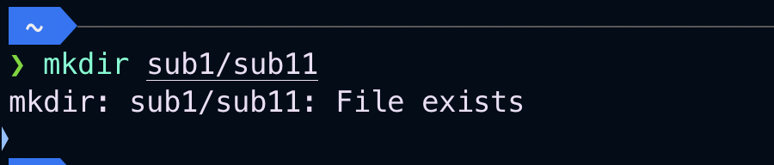
- Copy the file file1.txt from folder sub1 to folder sub1/sub11 without going to sub1 first. You need to refer to the file and folder using relative path.
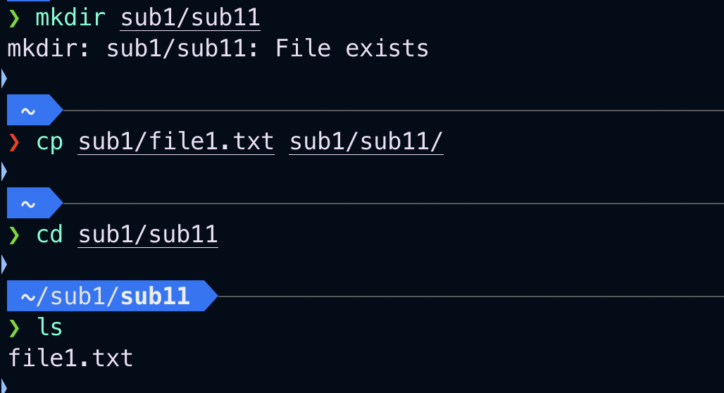
- Copy the file file2.dat from folder sub1 to folder sub1/sub11 without going to sub1 first. You need to refer to the file and folder using absolute path.
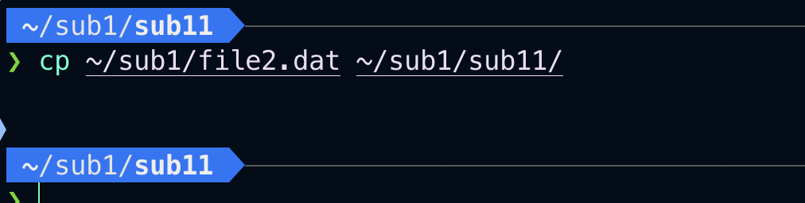
- Remove the folder sub1 and everything inside it with one command and without user confirmation.
